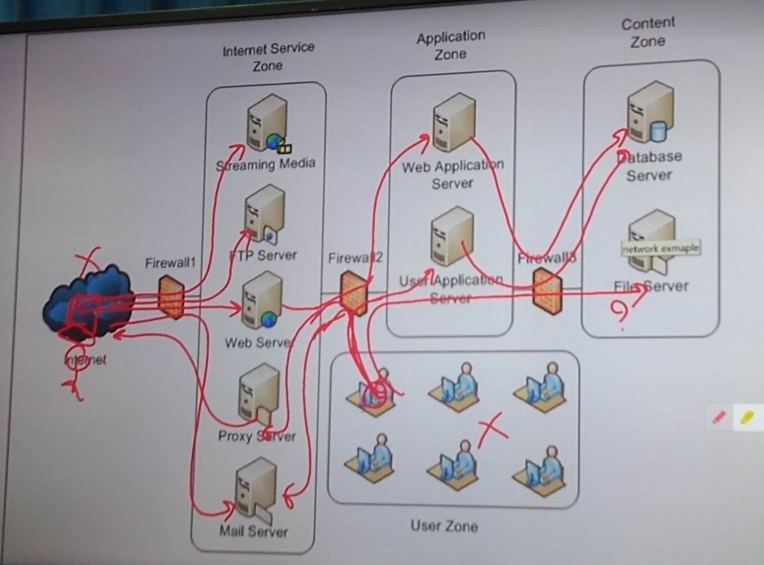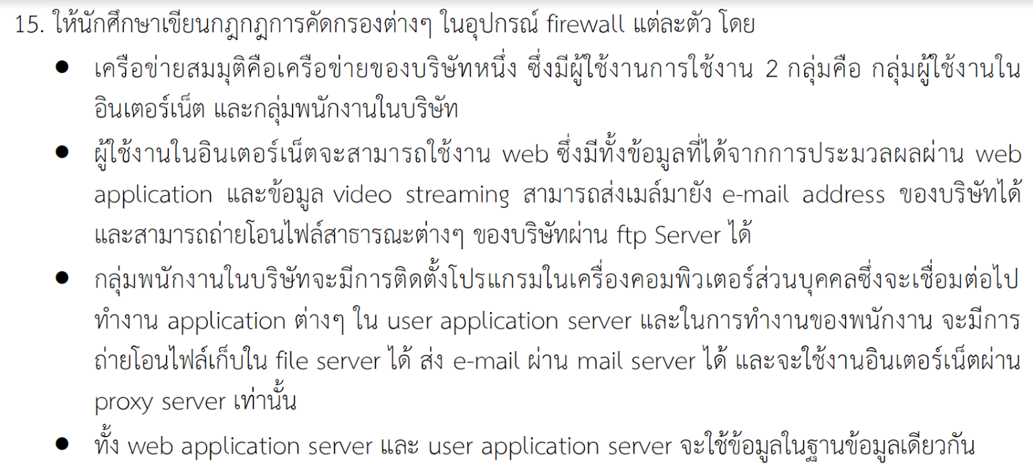

Firewall 1 policy

|  |  |  |  |
| --- | --- | --- | --- |
| S.ip | D.ip | Service | Action |
| Any | Streaming media | Any | Accept |
| Any | FTP Server | Any | Accept |
| Any | Web Server | Any | Accept |
| Proxy Server | Any | Any | Accept |
| Any | Mail Server | Any | Accept |
| Any | Any | Any | Deny |

Firewall 2 policy

|  |  |  |  |
| --- | --- | --- | --- |
| S.ip | D.ip | Service | Action |
| User zone | Proxy Server | Any | Accept |
| User zone | Mail Server | Any | Accept |
| User zone | User Application Server | Any | Accept |
| Web Server | Web Application Server | Any | Accept |
| Any | Any | Any | Deny |

Firewall 3 policy

|  |  |  |  |
| --- | --- | --- | --- |
| S.ip | D.ip | Service | Action |
| User Application Server | Database Server | Any | Accept |
| Web Application Server | Database Server | Any | Accept |
| User zone | File Server | Any | Accept |
| Any | Any | Any | Deny |